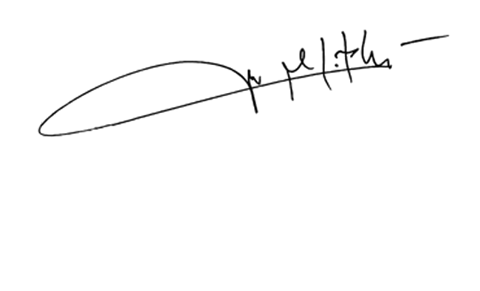

**MICAH NOEL PERPETUA, MD, FPCR**

**License no. 0134863**

**Radiologist**